ID | Type | Description | Priority | Acceptance Criteria | Rationale
FR-001 | Functional | The system shall allow the Club Lead to create and submit an event proposal containing event name, date, venue, description, expected participants, and proposed budget. | High | The Club Lead can enter all mandatory event details and submit the proposal. The system validates the required fields and generates a unique event ID. | Enables Club Leads to formally submit events for campus approval.
FR-002 | Functional | The system shall allow the Campus Admin to review submitted event proposals and approve or reject the proposed budget. | High | The Campus Admin can view event and budget details, approve or reject the proposal, and provide a reason when rejecting. The decision is recorded and visible to the Club Lead. | Provides controlled review and authorization of club events and expenditure.
FR-003 | Functional | The system shall allow the Club Lead to generate event tickets with unique QR codes for an event after the event has been approved. | High | The Club Lead can generate tickets only for an approved event. Each generated ticket has a unique ticket ID and QR code, and ticket availability is recorded by the system. | Enables authorized events to issue digitally verifiable tickets.
FR-004 | Functional | The system shall allow the Student to purchase tickets for approved events and receive a unique QR-code ticket after successful payment. | High | The Student can view approved events, select an event and ticket quantity, verify availability, complete payment, and receive a unique QR-code ticket. The purchase is recorded and available ticket count is updated only after successful payment. | Enables students to digitally purchase tickets and receive verifiable event access.
FR-005 | Functional | The system shall allow the Student to view or download their purchased QR-code ticket and allow the Club Lead to view ticket registration information for their event. | Medium | A student can view/download a valid purchased ticket. The Club Lead can view the corresponding ticket/registration information. | Allows students to access their tickets and Club Leads to monitor event registrations.
NFR-001 | Non-Functional | The system shall ensure that only authenticated and authorized users can access functions appropriate to their role. | High | Students, Club Leads, and Campus Admins can access only their authorized functions. Unauthorized access is denied. | Protects event, budget, payment, and ticket information.
NFR-002 | Non-Functional | The system shall respond to normal user requests within 3 seconds under expected system load. | Medium | At least 95% of requests under expected load receive a response within 3 seconds. | Ensures responsive use of the portal.

1. SYSTEM ACTORS
================================================================================

* Club Lead (Primary Actor):
Submits event proposals with budget requests, generates event tickets with QR codes after approval, and monitors registration records.

* Campus Admin (Primary Actor):
Reviews submitted proposals, evaluates proposed budgets, and records approval or rejection decisions with mandatory remarks.

* Student (Primary Actor):
Browses approved events, purchases tickets via payment processing, and downloads/views issued QR-code tickets.

2. LIST OF SYSTEM USE CASES

* UC-1: Submit Event Proposal & Budget
- Primary Actor: Club Lead
- Description: Allows the Club Lead to enter event metadata (name, date, venue, description, expected participants, budget) and submit the proposal.

* UC-2: Review & Approve/Reject Proposal
- Primary Actor: Campus Admin
- Description: Enables the Campus Admin to inspect submitted proposals and record an approval or rejection decision.

* UC-3: Generate Event QR Tickets
- Primary Actor: Club Lead
- Description: Allows the Club Lead to initialize and generate unique QR-code tickets for an approved event.

* UC-4: Purchase Event Ticket
- Primary Actor: Student
- Description: Allows the Student to select ticket quantities, process payment, and acquire an event ticket.

* UC-5: View & Download QR Ticket
- Primary Actor: Student
- Description: Enables students to access and download their issued QR-code tickets post-purchase.

* UC-6: View Event Registration Info
- Primary Actor: Club Lead
- Description: Allows the Club Lead to track participant registrations and ticket availability for their events.

* UC-7: Authenticate User
- Primary Actor: Shared (Club Lead, Campus Admin, Student)
- Description: Verifies credentials and enforces role-based access control.

* UC-8: Provide Rejection Remarks
- Primary Actor: Campus Admin
- Description: Logs formal justification when a budget proposal is rejected.

================================================================================
3. USE CASE RELATIONSHIPS («include» & «extend»)
================================================================================

A. «include» Relationships (Mandatory Sub-flows)
-------------------------------------------------
1. Purchase Event Ticket --«include»--> Authenticate User
Rationale: Students must be authenticated to complete ticket purchases and link passes to their accounts.

2. Submit Event Proposal & Budget --«include»--> Authenticate User
Rationale: Requires verified Club Lead authentication to prevent unauthorized submissions.

3. Review & Approve/Reject Proposal --«include»--> Authenticate User
Rationale: Requires administrative sign-in to access approval privileges.

B. «extend» Relationships (Optional / Conditional Flows)
--------------------------------------------------------
1. Provide Rejection Remarks --«extend»--> Review & Approve/Reject Proposal
Extension Point: Proposal Rejected
Rationale: Only executed when the Campus Admin rejects an event/budget proposal.

================================================================================
4. REQUIREMENT TRACEABILITY MATRIX (MAPPING TO MEMBER 1 FRs)
================================================================================

Requirement ID | Requirement Description | Associated Use Case | Primary Actor
------------------------------------------------------------------------------------------------------------------------
FR-001 | Event Proposal & Budget Submission | UC-1: Submit Event Proposal & Budget | Club Lead
FR-002 | Review & Approve/Reject Proposal | UC-2: Review & Approve/Reject Proposal | Campus Admin
FR-003 | Generate QR Tickets for Approved Events | UC-3: Generate Event QR Tickets | Club Lead
FR-004 | Purchase Event Ticket via Payment | UC-4: Purchase Event Ticket | Student
FR-005 | View/Download Tickets & Monitor Regs | UC-5: View & Download QR Ticket / | Student /
| | UC-6: View Event Registration Info | Club Lead
================================================================================

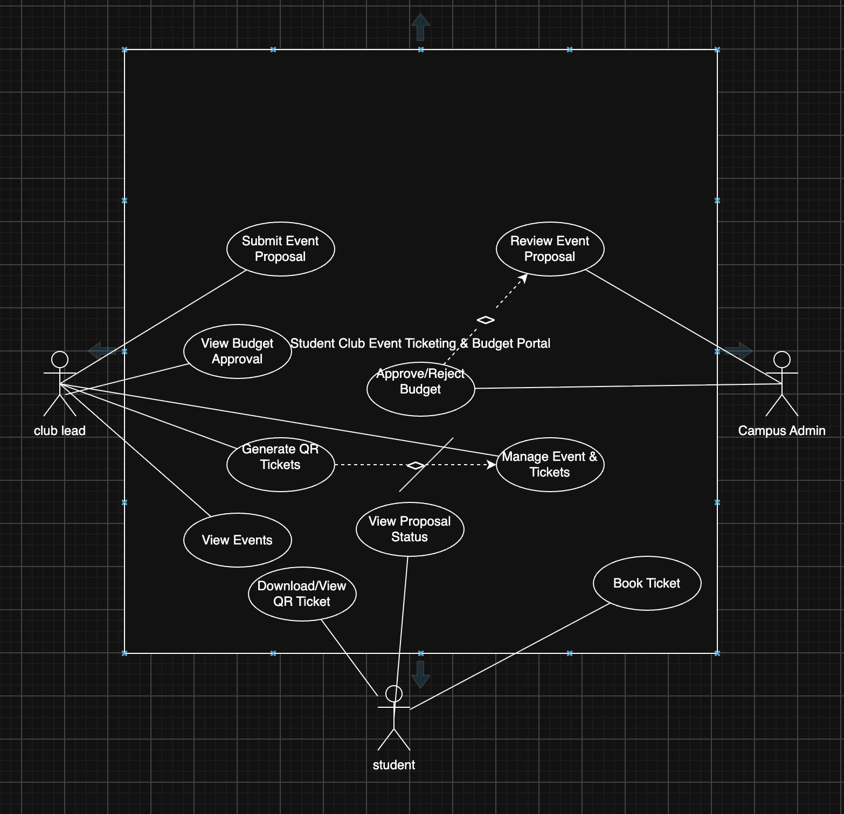

Use Case: Book Ticket
Primary Actor: Student

Preconditions
- The Student is an authorized user of the portal.
- Approved events are available in the system.
- Tickets are available for the selected event.
- The selected event is open for ticket booking.

Postconditions
Success:
- The student's ticket booking is recorded.
- The available ticket count is updated.
- A unique QR-code ticket is generated/assigned.
- The Student can view or download the QR ticket.
Failure:
- The ticket is not booked.
- The available ticket count remains unchanged.
- No QR-code ticket is issued for the failed booking.

Main Success Scenario
- The Student selects “View Events” from the portal.
- The system displays the available approved events.
- The Student selects an event they wish to attend.
- The system displays the event details, including event name, date, venue, and ticket availability.
- The Student selects the required ticket quantity and chooses “Book Ticket.”
- The system verifies that the requested number of tickets is available.
- The system processes the ticket booking and records the Student's registration.
- The system updates the available ticket count.
- The system generates/assigns a unique QR-code ticket to the Student.
- The system displays a booking confirmation.
- The Student selects “Download/View QR Ticket.”
- The system displays the purchased ticket and its unique QR code.
- The Student can view or download the QR-code ticket.
- The use case ends successfully.

Alternate Flow – Tickets Unavailable
6.1 The system determines that the requested number of tickets is greater than the available tickets.
6.2 The system displays a “Tickets Unavailable” message.
6.3 The Student is asked to select a smaller quantity or choose another event.
6.4 If the Student selects an available quantity, the flow continues from Step 7 of the Main Success Scenario.
6.5 If the Student cancels, no booking is recorded and the use case ends.

Alternate Flow – Booking Failure
7.1 The system is unable to complete the booking.
7.2 The system displays a “Booking Failed” message.
7.3 The system does not reduce the available ticket count.
7.4 The Student may retry the booking or return to the event list.
7.5 If the retry succeeds, the flow continues from Step 8 of the Main Success Scenario.
7.6 If the Student cancels, the use case ends unsuccessfully.

